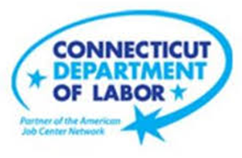

**NEW WEEKLY JOB POSTINGS FROM   
HELP WANTED ONLINE  
Office of Research**

**Week Ending March 26th, 2022:   
New Ads Down Slightly Over The Week But March Monthly Average Remains High**  
WETHERSFIELD, April 1st, 2022 – During the week ending March 26th, 2022, there were 8,518 new postings, down 122 new ads from the week ending March 19th. This slight top-line decrease overlays larger shifts among the 21 major industry groups. 8 industries declined over the week by a combined -710 new ads, two were unchanged, and the 11 gaining industries had a combined 588 new ads increase. The largest industry decrease and increase respectively were Accommodation & Food Services (-117 new ads) and Real Estate & Rental & Leasing (+159 new ads). The largest respective employer shifts among those two industries were Domino’s Pizza (-11 new ads) and Berkshire Hathaway (+119 New Ads). The four weeks ending in March 2022 went from a March 5th series high of 12,707 new ads to the most recent week’s 8,518 level. This is the largest intra-month spread since July 2021. The most recent 4-week average is 9,832, the highest on record due to the series high of March 5th. Excluding that peak, the most recent 3-week average is 8,873, which is still among the top 10 three-week averages in the new ad data series. The most recent week is up 42% from a year ago. The graph below shows how monthly averages dipped in December and January but have increased over the past two months.

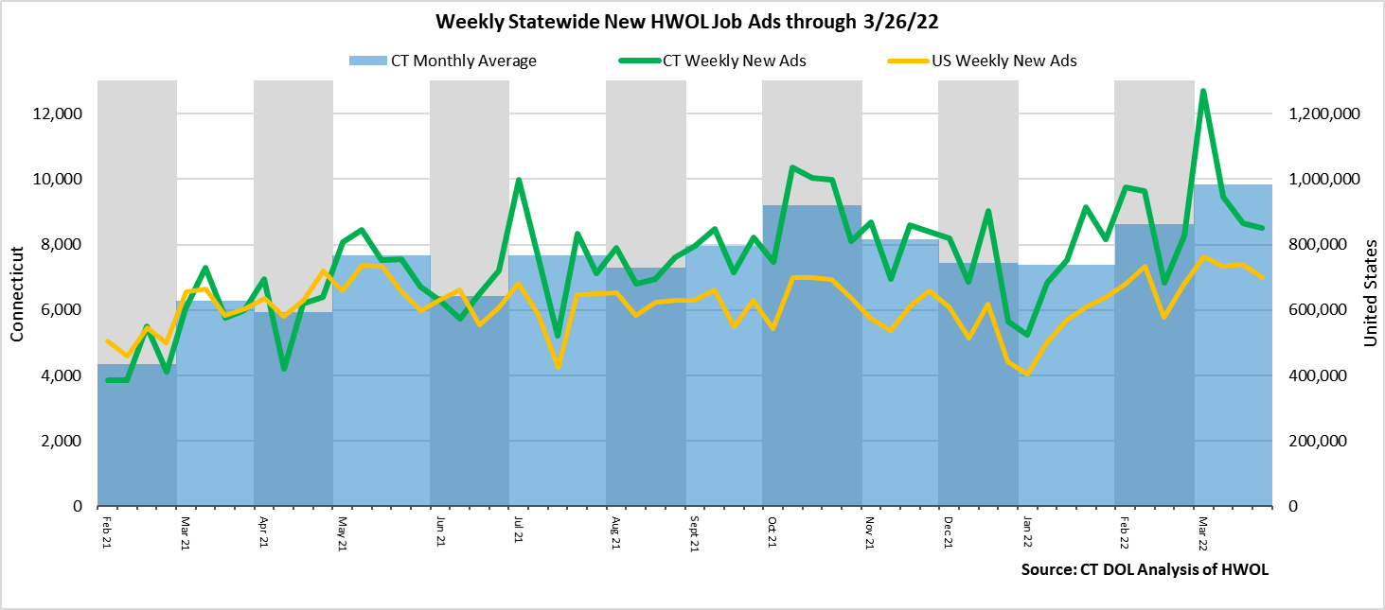  
 **Industries** with the most new postings include Health Care & Social Assistance, Finance & Insurance, and Retail Trade.

**Occupations** with the most new postings include Registered Nurses, Retail Salespersons, and Wholesale & Manufacturing Sales Representatives.

**Employers** with the most new postings include Hartford Healthcare, Yale-New Haven Health System, and UnitedHealth Group.

**The three industries with the most new job postings where:**

* **Health Care & Social Assistance** (1,995 new postings, +5% over the week)
* **Finance & Insurance** (799 new postings, -16% over the week)
* **Retail Trade** (702 new postings, -9% over the week)

   
 The most recent week saw large percent shifts for most industries. 14 out of 21 industries had shifts of over 10%, some of the largest being Real Estate (+164% or +159 new ads), Admin. & Support (+39% or +72 new ads), Wholesale Trade (+39% or +27 new ads), and Accom. & Food Service (-22% or -117 new ads). Over four weeks, total ads were up 1,596 or +23.1%, with 14 industries positive and 7 negative. The largest of each over four weeks were Health Care & Social Assistance (+768 new ads or +63% ) and Accommodation & Food Services (-134 new ads or -25%).  
  
 For more information on total job ads by industry for Connecticut and its labor market areas, see the monthly report available here: <https://www1.ctdol.state.ct.us/lmi/hwol.asp>

**New Job Postings by Occupation** 

**The occupations with the most new postings were:**

* Registered Nurses (680 new postings, -4% over the week)
* Retail Salespersons (202 new postings, -11% over the week)
* Sales Representatives, Wholesale and Manufacturing (170 new postings, -4% over the week)
* Heavy & Tractor Trailer Truck Drivers (170 new postings, +10% over the week)

**Employers with the Most New Job Postings**

Employers with the most new job postings during the week were mostly in Healthcare, Finance & Insurance, and Retail Trade. The 25 employers shown above account for 20 percent of all new ads. Among the top 25 employers, 22 had over the week ad increase and 3 had decreases. The largest increasing employer over the week was Yale-New Haven Health System (+126 new ads) and the largest decreasing employer was Hartford Healthcare (-76 new ads). Over four weeks, 19 of 25 employers shown above had increases, one was unchanged, and 5 had decreases. The largest of each were Hartford Healthcare (+283 new ads) and Compass Group North America (-53 new ads).  
   
**What is HWOL?**The **Conference Board Help Wanted Online**® Data Series (HWOL) measures the number of new, first-time Online job postings and jobs reposted from the previous month for over 16,000 Internet job boards, corporate boards and smaller job sites that serve niche markets and smaller geographic areas. To view more HWOL data, go to: <https://www1.ctdol.state.ct.us/lmi/hwol.asp>